OOP Assignment 2
Car Marketplace System

Rabisa Ali (25K-0876)
BCS-2C

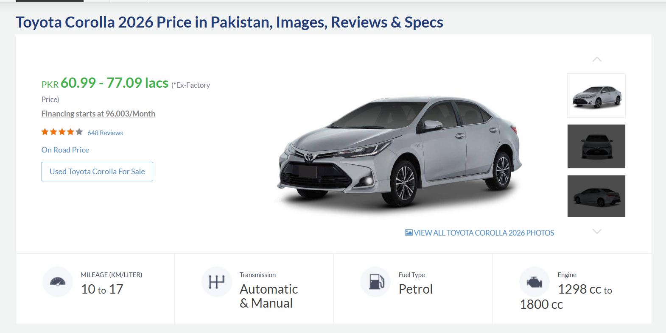
The following car has attributes like price, mileage, model, and brand etc.
This has been implemented in the code by making a class named as Car which inherits some attributes from Vehicle class and has some attributes of its own like mileage, numDoors and fuelType. This class also have some overloaded operators and is further inherited by Electric Car too.
Similarly, there is another Bike class too which also inherits from Vehicle class.
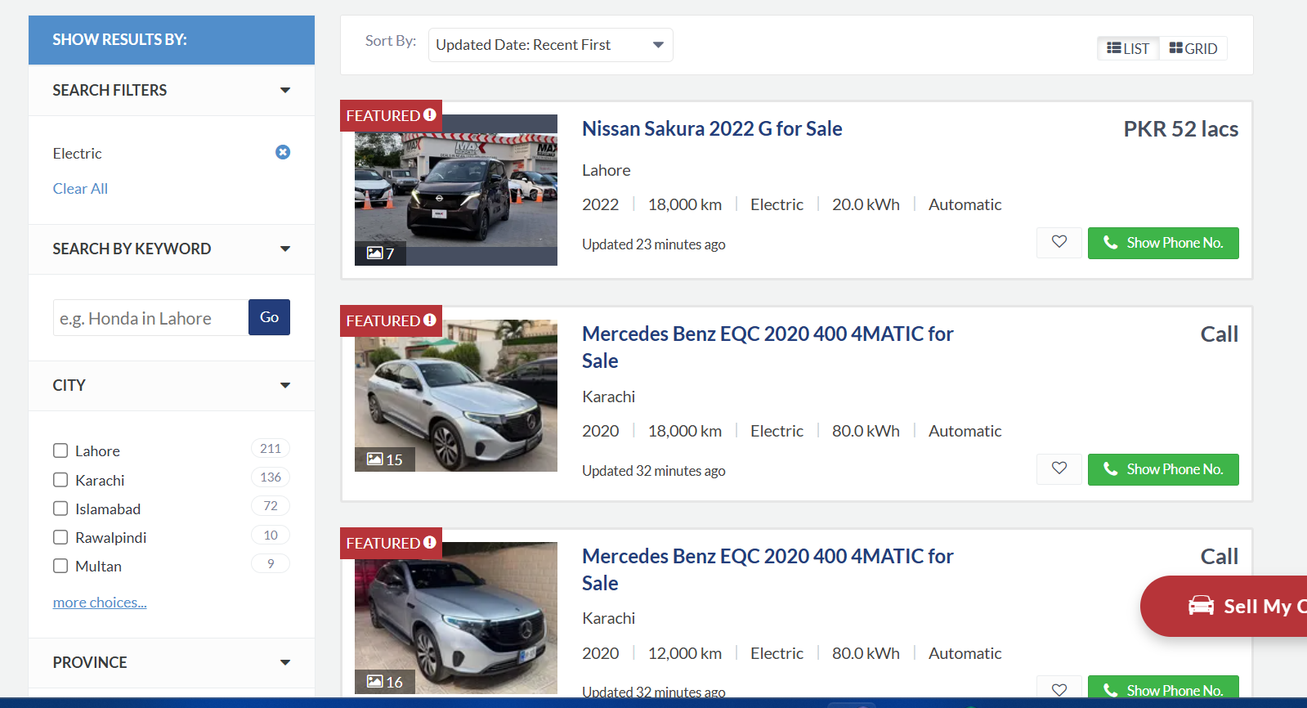
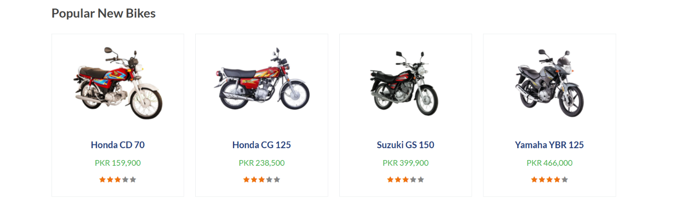
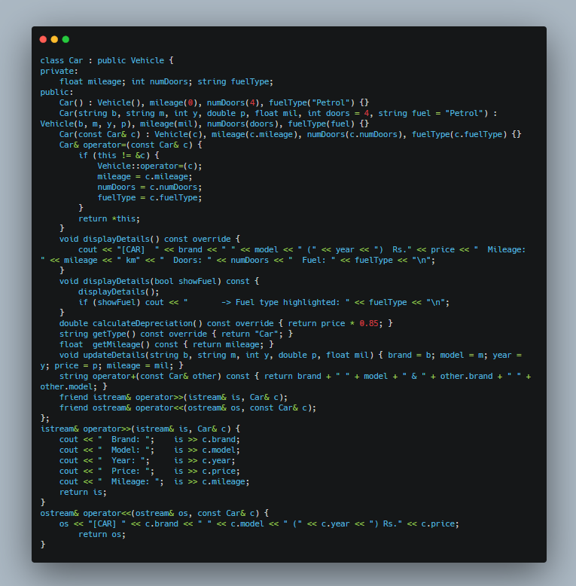
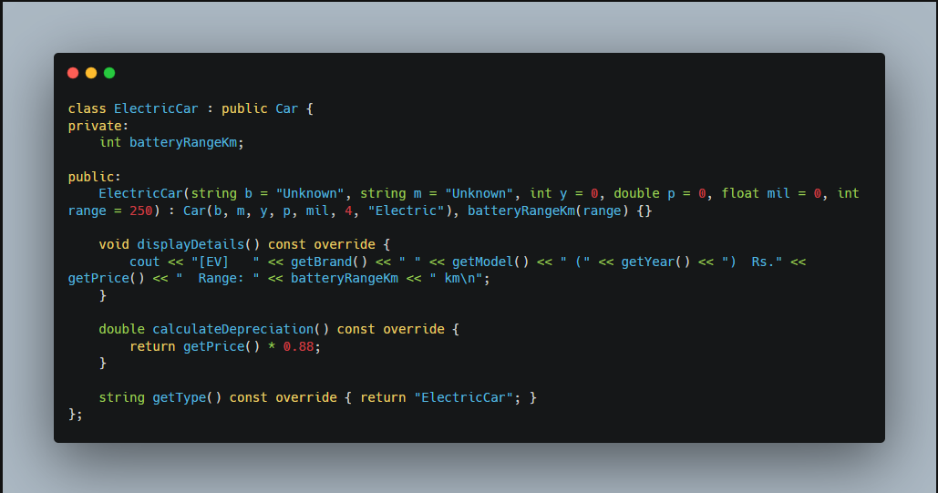

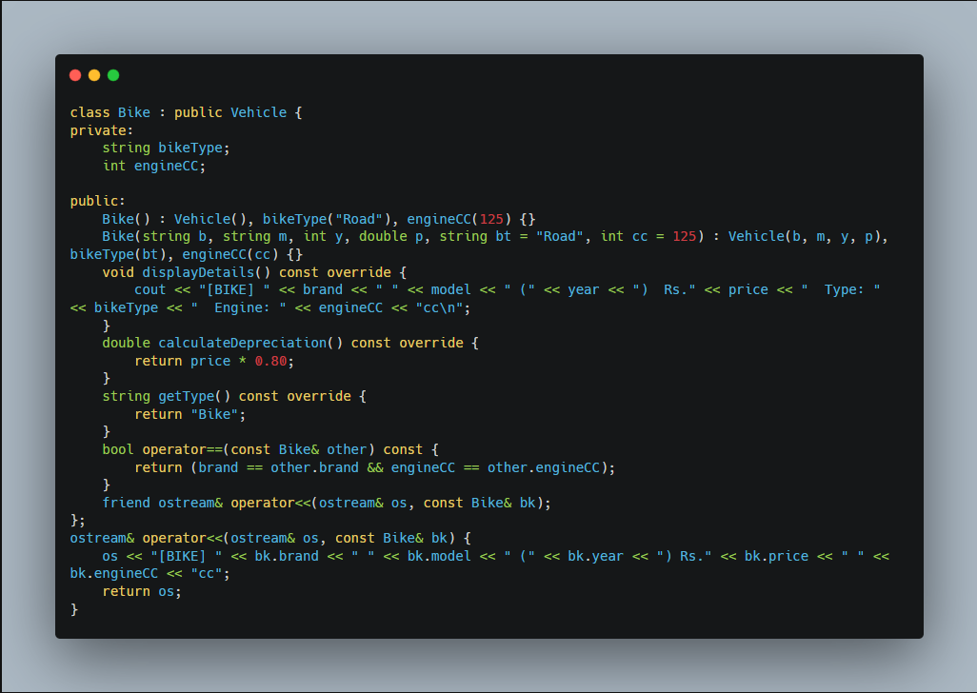
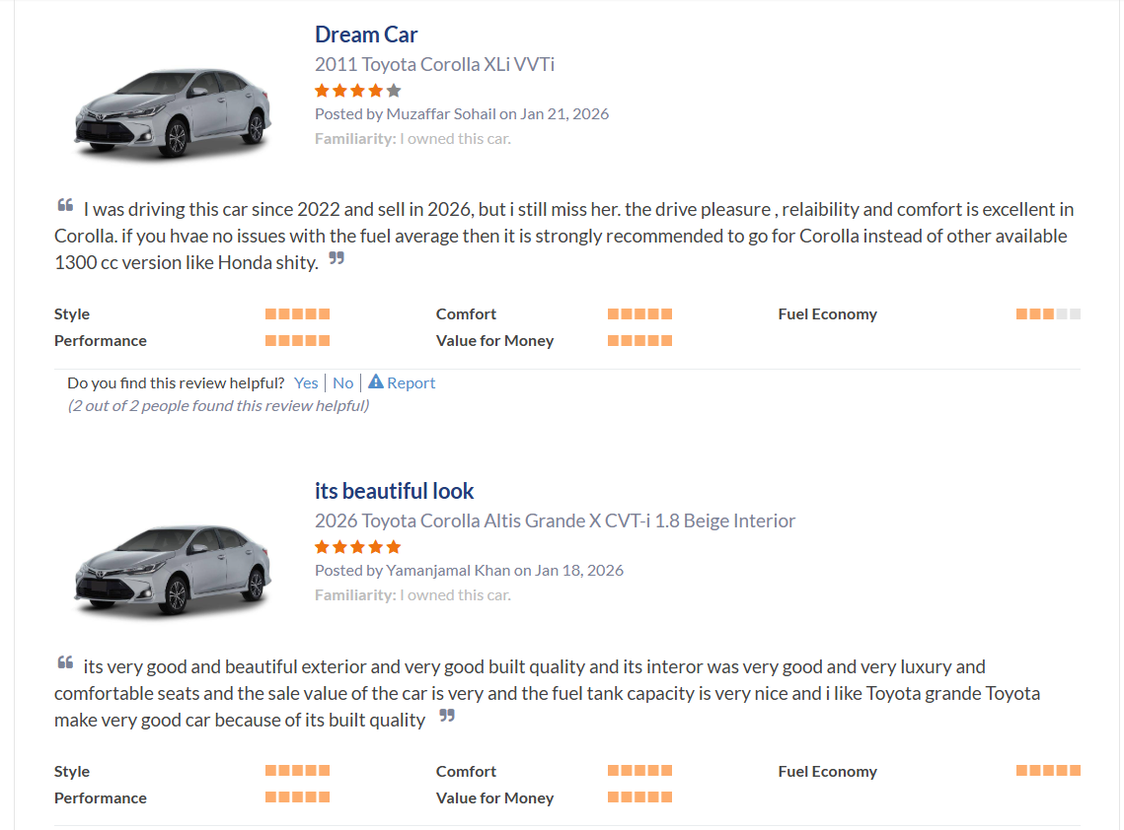
The review system of the PakWheels has been cloned in the code by making up a class named Review which has the attributes of review ID, reviewer ID, seller ID, rating, the comment, and the date of the comment. This class also have some overloaded operators like == and << (to display outputs).
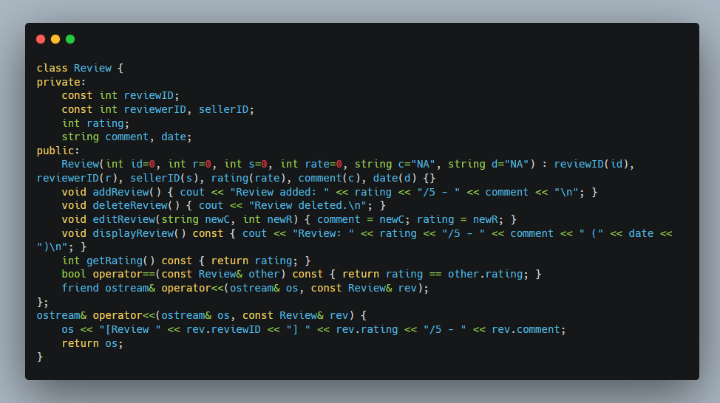

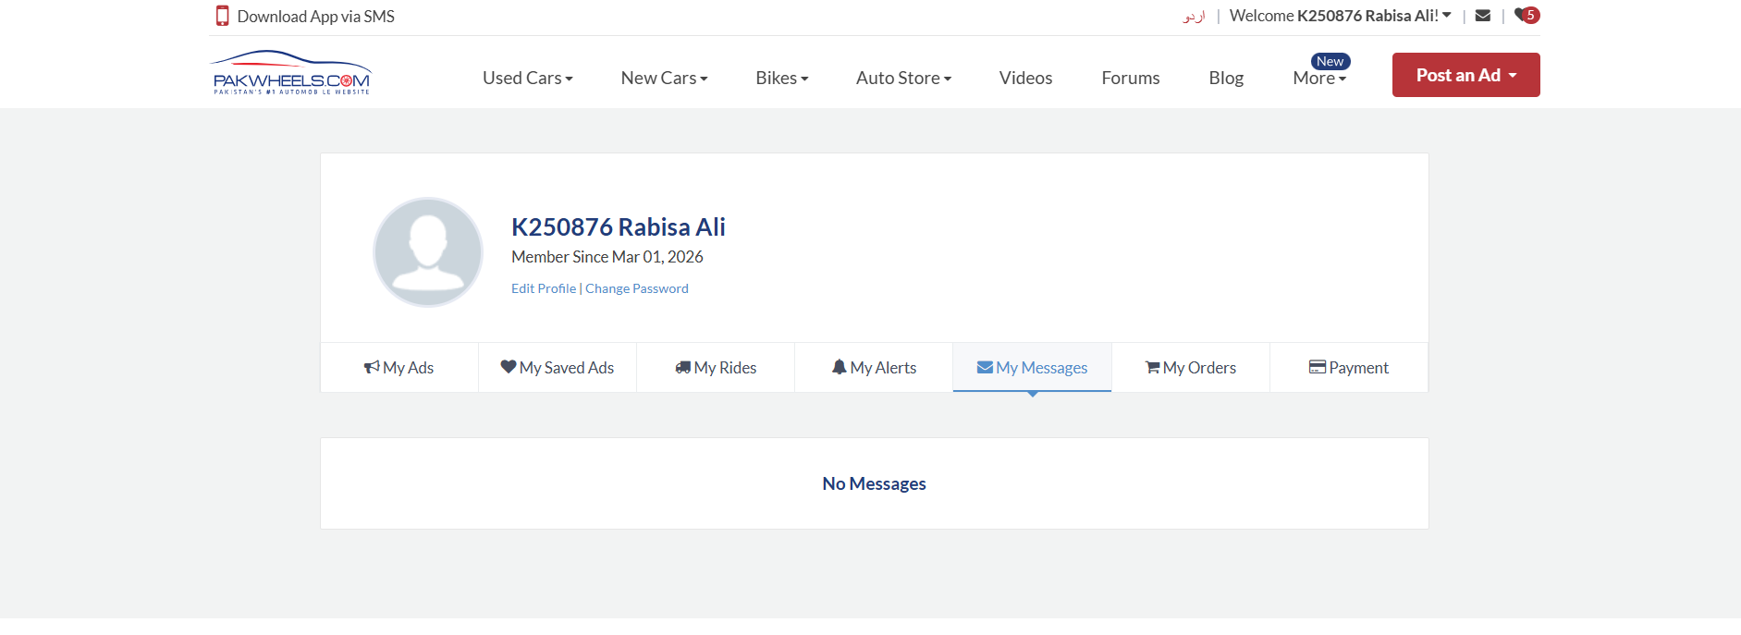
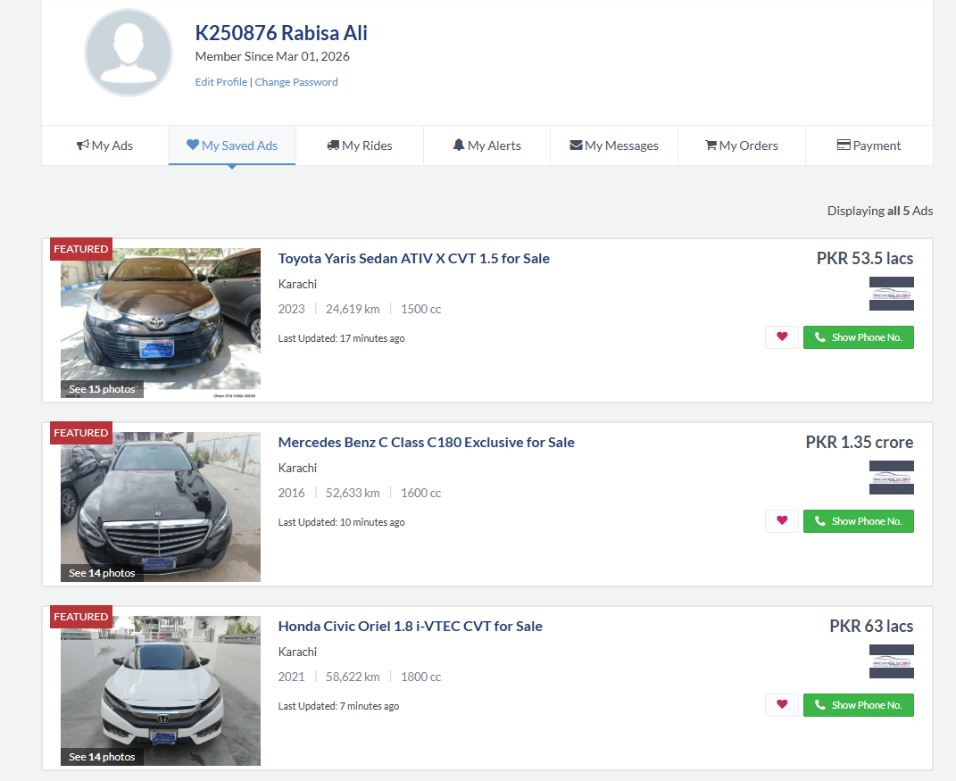

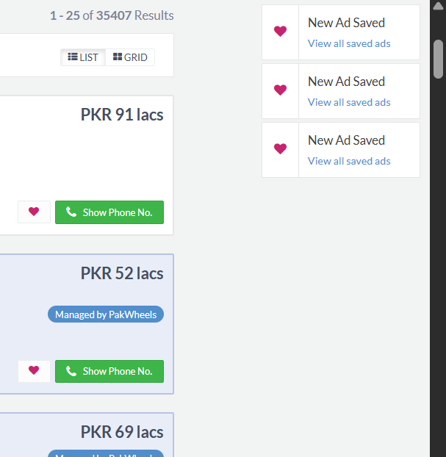

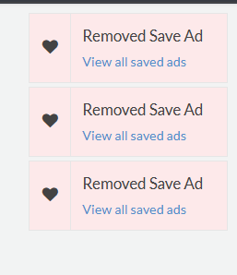
To implement a similar functioning, I created a class named User. User has a password and an isLoggedIn Boolean attribute.
This User attribute is then further inherited by Buyers and Sellers.
Buyer is able to add a favorite car.
This class also involves composition when it comes to the favorites which has a type of car. This class also has a friend function of compareBuyers, and is also further inherited by TrustedBuyer.
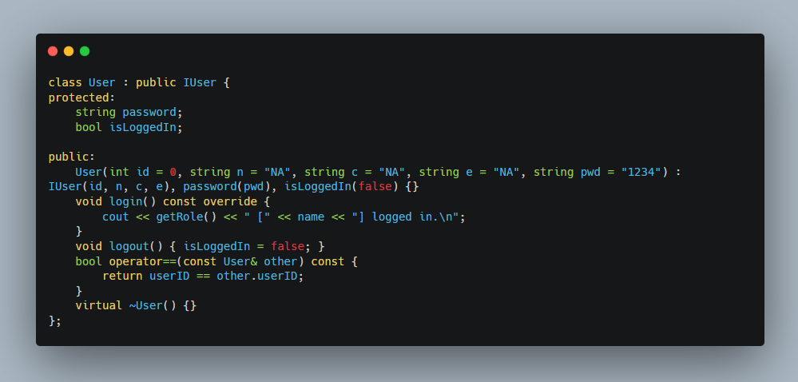

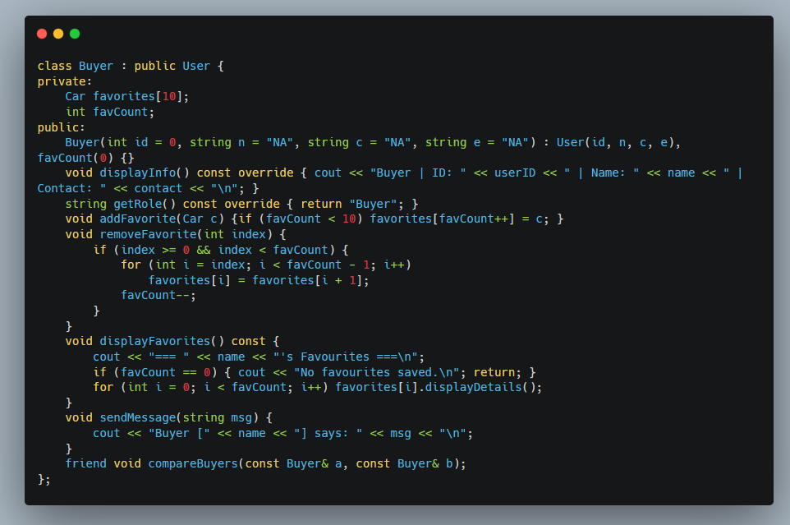

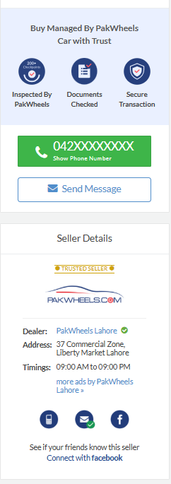
With every Ad that is posted on PakWheels, the seller’s details are displayed including their location, and number.
In order to mimic this in my code, I have made a Seller class which inherits from User class and has some additional attributes like sellerRating, cars array(composition), and sellerReview(composition). This class also declares a friend class named Admin and a friend function called compareSellerRatings.

The Seller class have a sellerRating, Cars array, and a sellerReview attributes. This class also involves composition. This class is then also inherited by other like PremiumSeller.
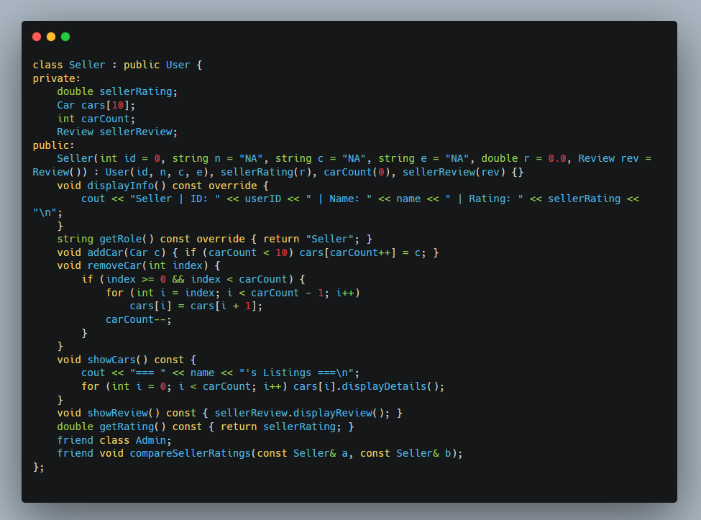

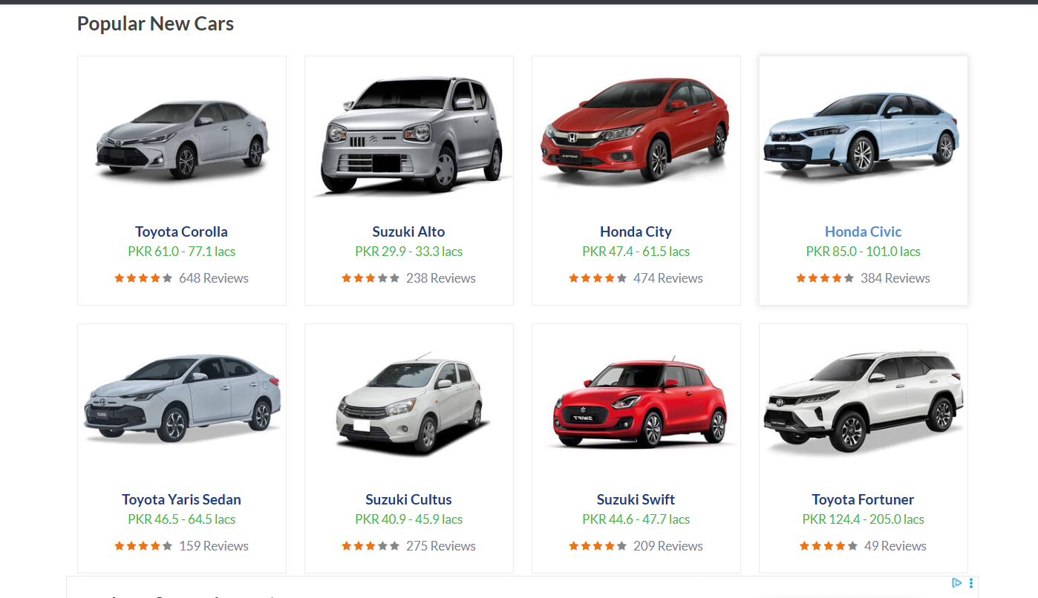
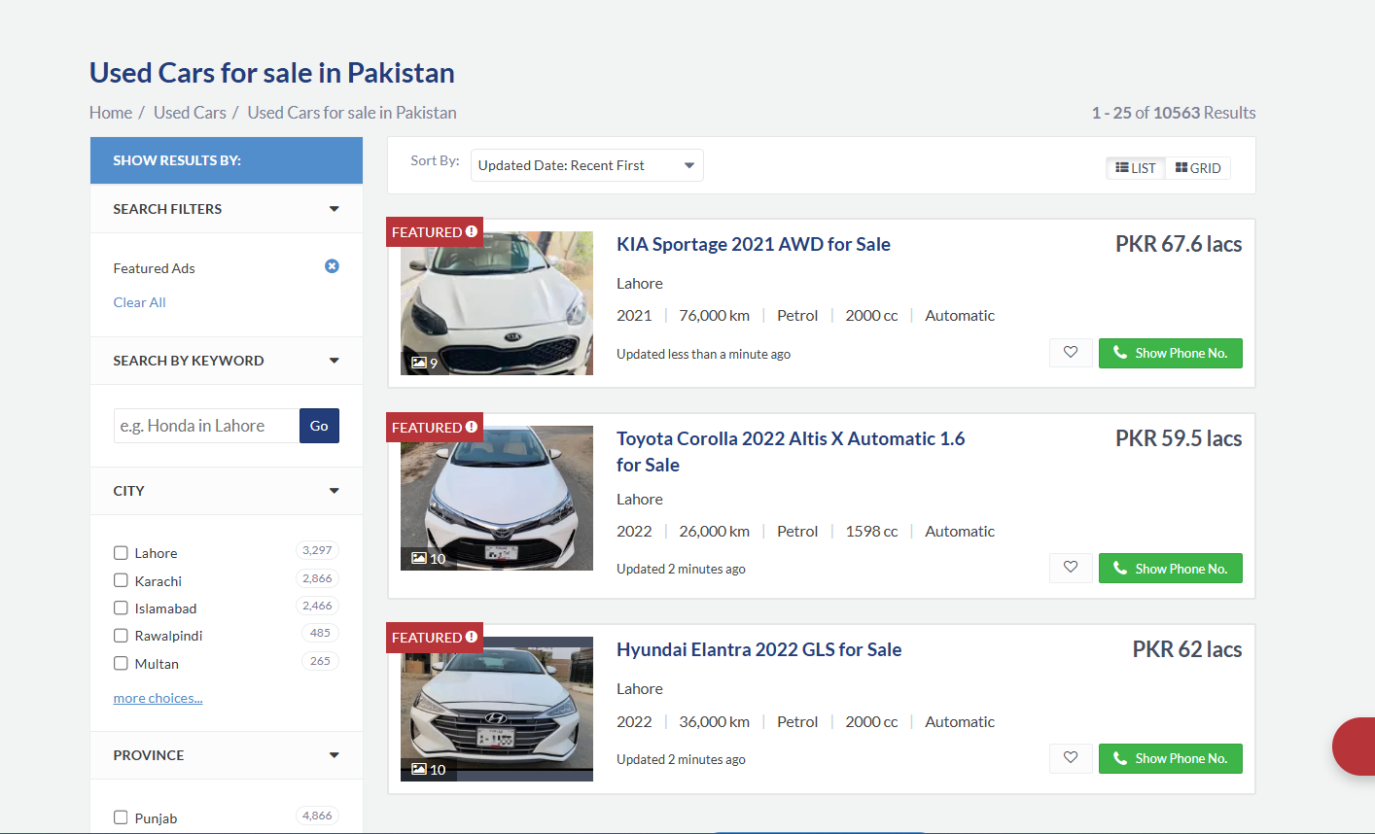
The PakWheels website lists the cars in this manner. To clone this part in my code I introduced a new class by the name of Listing. This class has multiple data attributes like listing ID, vehicle pointer(aggregation), the date the ad was posted. This class also inherits from a IListable which is an abstract class.
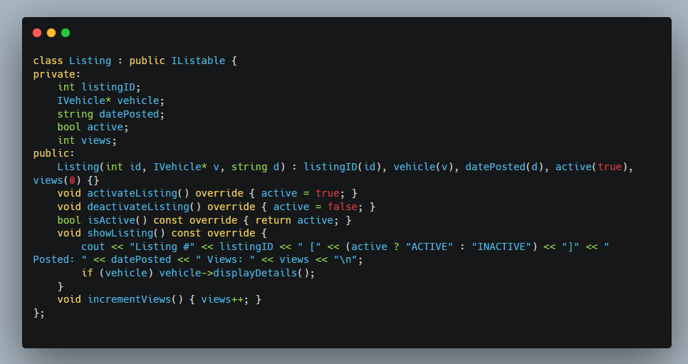

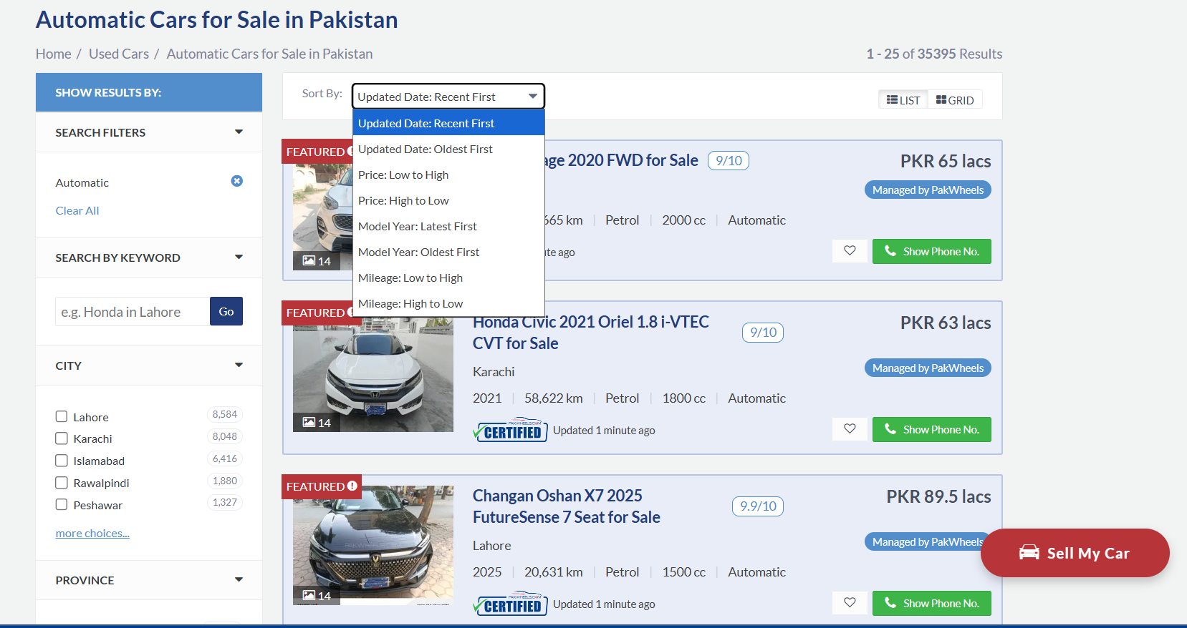

On the website there is an option to search and sort by filters, to implement this functionality in my code I introduced a new class by the name of SearchFilter. This class does the job by searching, matching, and then applying the filter and then finally showing the result.
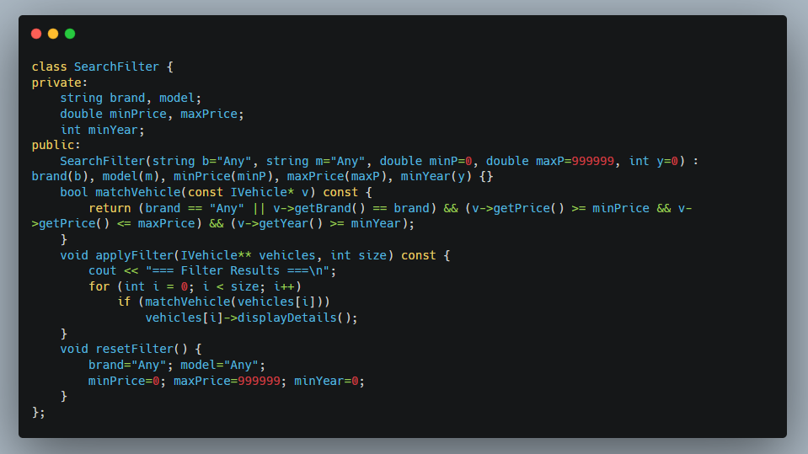

PakWheels also has a marketplace where you can get an overall idea of the services provided by the website and the types of cars sold.
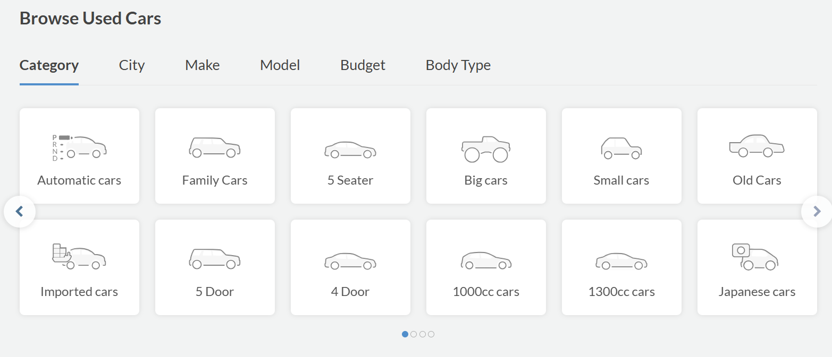
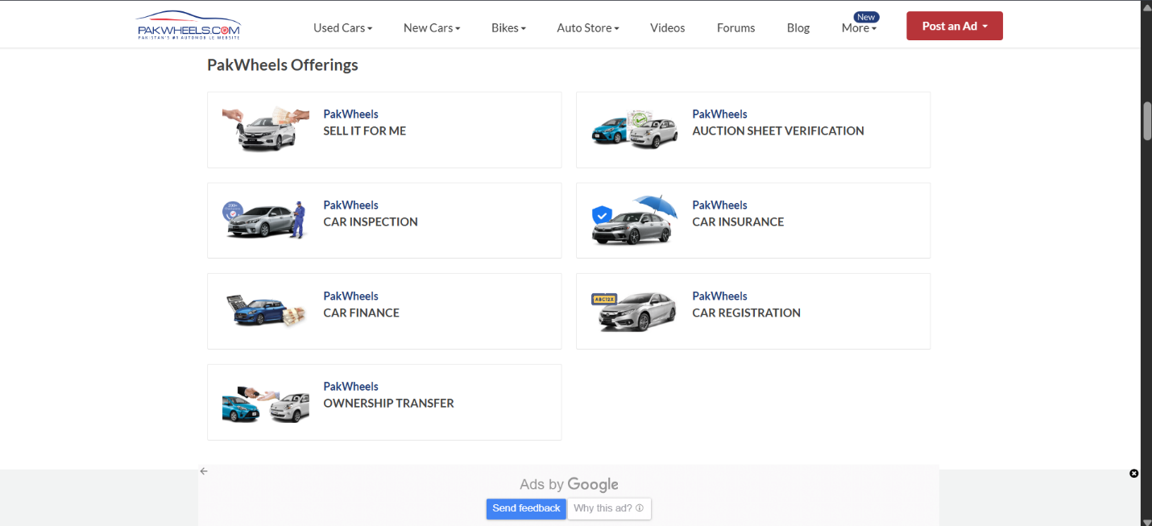
In order to implement this marketplace concept in my code, I created a marketplace class which consisted of a system name, listings of all the things being sold(aggregation), sellers’ profiles(aggregation) and their count along with total users count (using static data attribute).
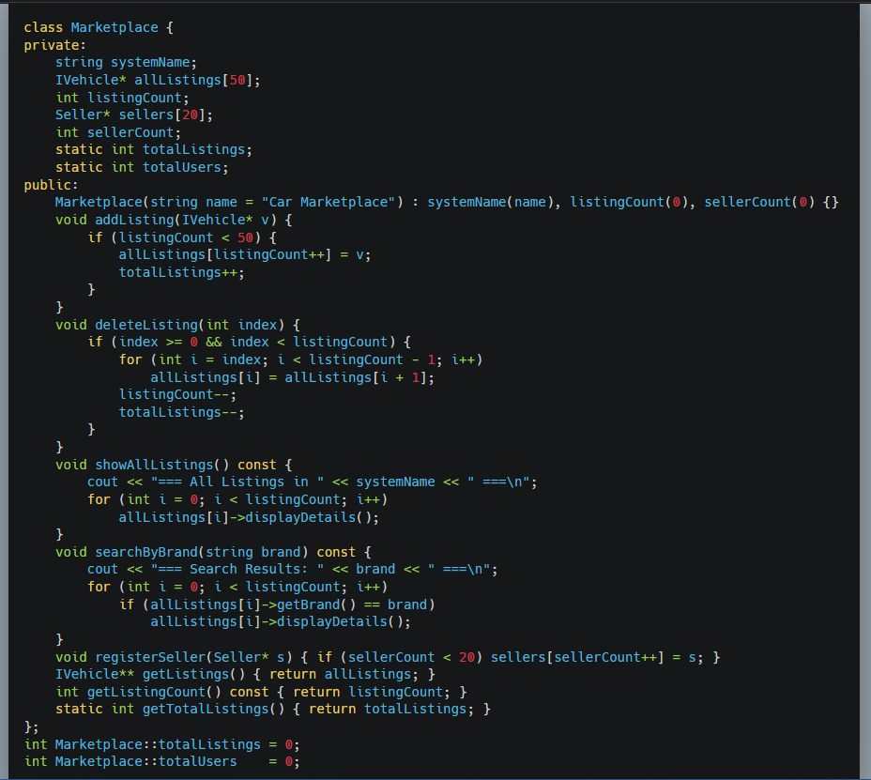
There are other classes in the code too like Vehicle, Payment, Message, and Admin etc. including some other abstract classes too. Together they all extend the functionality of this program.

